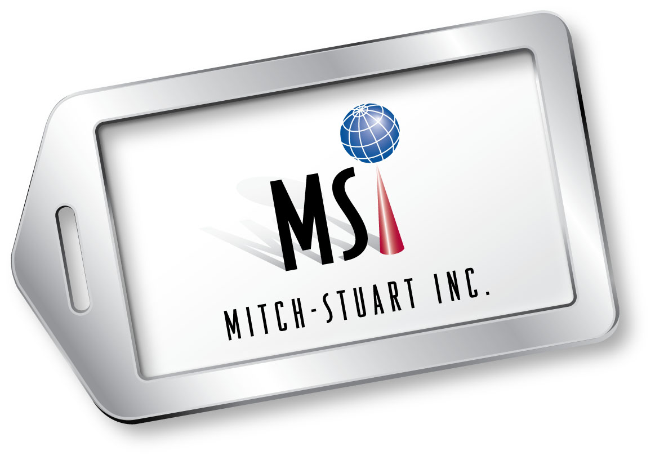

MITCH-STUART, INC.

MILESTONES/MAJOR ACCOMPLISHMENTS

- Michelle Cohen and Stuart Paskow create and launch the first-ever nonprofit rewards program—the Frequent Funder Awards Program®—to encourage continuous giving.

1994 Mitch-Stuart, Inc. (MSI) is formed as a private corporation and originates American Airlines AAdvantage Fundraising™ - the first program to offer frequent flyer mileage to charities across the nation.

1994 MSI raises its first million dollars for charitable organizations.

1995 Wall Street Journal features MSI on front page lead story.

1995 MSI authors the highly acclaimed United Way Donor Awards program.

1996 MSI creates nationwide custom charity award with Tiffany & Co.

1997 Delta Air Lines recruits MSI to develop and create nonprofit mileage program.

1997 MSI works with South Florida Community Blood Centers to create “Miles for
Mondays.”

1998 MSI and the National MS Society create program to award American Airlines
AAdvantage® Miles and round-trip flight certificates to event fundraising
participants.

1998 MSI works with New York Blood Services to award miles to alleviate severe blood shortage--over 15,000,000 miles awarded.

2000 MSI works with KMEL contemporary radio station to create “Kick for the

Miles,” a program with American Airlines AAdvantage®, Stanford University,

Dr. Pepper, Kmart and Nike.

2001 MSI facilitates mileage fundraising program with UNICEF to raise funds to help
children worldwide.

MSI Milestones Page 2

2001 MSI teams with the American Cancer Society to create 1,000,000 Miles
Sweepstakes.

2003 MSI implements “USO Cares,” a program to sponsor USO care packages for
service members deployed overseas

2005 MSI receives Freddie Award for Distinguished Achievement. (Freddie’s
are the most prestigious awards in the hospitality industry named in honor of the legendary aviation magnate Sir Freddie Laker).

2005 MSI creates and trademarks Destinations of Excellence® - the first no-risk
travel package program for charitable auctions and donor recognition.

2006 Michael Upp joins MSI as Senior Vice President of Business Development.

2006 MSI launches a new business-to-business incentive travel program.

2007 MSI creates and launches its successful B2B division to offer travel rewards programs to businesses.

2008 Michelle Cohen and Stuart Paskow establish Mitch-Stuart, Ltd. in the UK,
introducing charity incentives to the UK and Europe.

2009 Cutting-edge Corporate Employee Auction pilot program is launched to build strong communities and socially responsible corporations.

2009 Michelle Cohen selected to committee that promotes “green travel” initiative.

2010 One billion dollars is raised for charities through MSI programs.

2010 MSI creates and launches Perfect Places®, a breakthrough travel program that enables businesses to offer a low cost employee benefit while raising funds for designated charities.

2012 Michelle Cohen and Stuart Paskow are highlighted in featured article in Forbes magazine.

2013 MSI celebrates its 20th anniversary in fundraising.

2013 MSI wins national SCORE Award for Outstanding Small Business Launched by an Individual 50+.

MSI Milestones Page 3

AWARDS/AFFILIATIONS/RECOGNITIONS

- Michelle Cohen named outstanding Alumni at the University of California, Irvine, for being the most successful graduate of its Fundraising Program.

- Michelle Cohen was recognized as one of OC Metro’s 20 Women to Watch 2010.

- Michelle Cohen was featured nominee for the Orange County Business Journal’s 2010 Excellence in Entrepreneurship Awards.

- Michelle Cohen was featured nominee of the Orange County Business Journal’s Women In Business 2010.

- Michael Upp received the Rising Star Award from the Incentive Marketing Association and Marty Wittig Volunteer Award for Safehouse, Denver.

- Stuart Paskow was honored as a lifetime member of Strathmore’s Who’s Who global registry and network of outstanding professionals for his leadership in the travel incentive industry.

- Stuart Paskow served on the Small Business Administration Advisory Board and the New Jersey Hotel Association Board of Directors.

- Michelle Cohen and Stuart Paskow served on the Incentive Customer Forum for Marriott Hotels & Resorts and The Ritz-Carlton.

- Michelle Cohen and Stuart Paskow served on the Customer Advisory Board for Fairmont Hotels & Resorts.

- The company sponsors the annual Nonprofit Times’ Power & Influence Top 50 Gala and was honored as the founding charter sponsor.

- Michelle Cohen and Stuart Paskow served as fundraising consultants to American Airlines for 20 years.

- Michelle Cohen and Stuart Paskow were honored by receiving the national SCORE Award for the Outstanding Small Business Launched by an Individual 50+.

# # #

