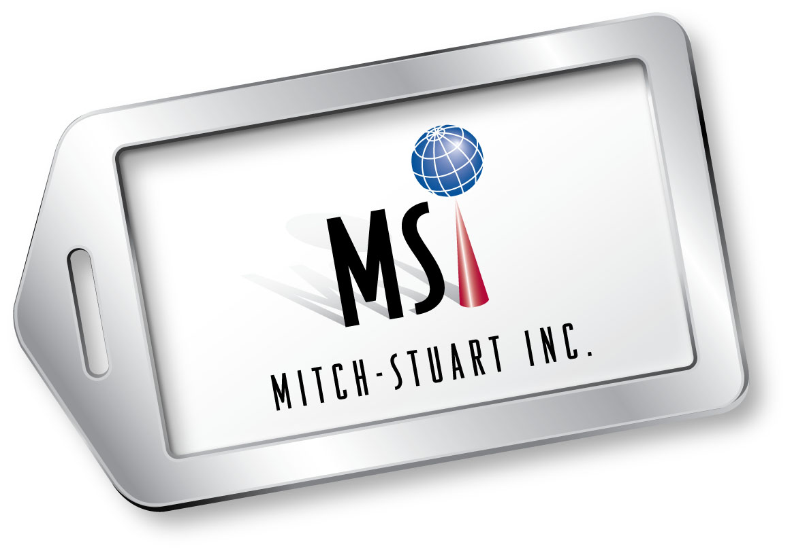
MITCH-STUART, INC.

Vendor Testimonials

“American Airlines and Mitch-Stuart, Inc. have been partners for almost 14 year and Mitch-Stuart has grown to be one if American’s top clients in recent years. We are pleased to support Mitch-Stuart in their efforts to help raise millions of dollars for the nonprofit community.”
Michael Hartman – Former Manager, New Business/Product Development
American Airlines

“As the program manager of the American Airlines’ incentive program, I was elated to learn of the Mitch-Stuart business model – an efficient and smart way to reach the very vast charity world. Through Michelle and Stuart’s efforts, I have increased awareness of AA’s commitment to supporting benevolent and compassionate organizations. And most of all, the two are thorough, provide excellent customer support, and have proven to be wonderful stewards of the company.”
Jennifer Tillman – Former Manager, Incentive Travel Products
American Airlines

“The need for a charity to raise money for its cause is critical to the charities survival, research and ability to extend help to its community. This call for assistance definitely grows profound as the reality of staffing levels and dedicated time to solicit and package auction prizes within each organization becomes slim. Enter: Mitch-Stuart. Mitch-Stuart is a highly professional company that has focused its attention on this necessity and has come to the rescue with solid understanding and a compassionate solution to the dilemma. Mitch-Stuart has the ability to organize prizes for charitable auctions with no-risk to the organization and has ultimately become a guiding light for all they serve. I am amazed at their total customer care from organizing the package to the recipient support. Mitch-Stuart is a first class full service company dedicated to assisting charities with their bottom line. Marriott is proud to be included as one of their many partners on these very valuable programs.”
Peggy Whitman, CITE - Sr. Manager, Western U.S. Regional Sales Offices
Marriott International
“Working with Mitch-Stuart, Inc. has provided us the opportunity to let the public know that Fairmont Hotels & Resorts believe that customer service and community service are synonymous. Our investment in local and national charities and the critical work they provide to those in need is an accomplishment in which we take great pride. Mitch-Stuart has helped Fairmont to become recognized as a socially responsible leader in the charitable giving community, and has enabled Fairmont to extend our help to new and deserving organizations providing critically need services to those in need. We are proud of our good name and our good work.”
Robert Ward - Director of Sales, Ovation Rewards
Fairmont Hotels & Resorts / Raffles Hotels & Resorts

(more)
MSI Vendor Testimonials Page 2

“Mitch-Stuart is comprised of a professional team dedicated to ensuring the highest of customer service. Four Seasons Hotels and Resorts was recently included in their portfolio and are proud to be associated with their organization. They fulfill a true need in the charity arena and solution for corporations to meet their desire to give back to the community.”
Lynn Pavony
Director of Incentive Sales
Four Seasons Hotels and Resorts

“Raising $1billion for charity is quite an accomplishment – congratulations! We’re very proud to be partnered with Mitch-Stuart. Thank you for your continued support. Looking forward to seeing you both again soon…”
Greg Whitacre
Former Sr. Director of Global Sales
Marriott Individual Incentives

“Happy 16th anniversary and congrats on reaching the $1 billion mark! That’s quite an accomplishment, especially when I think of the non-profit organizations that have benefited. We are proud to be your partners!”
Stacey Milne
Vice President, Global Incentives and Gift Cards
Marriott International

# # #

