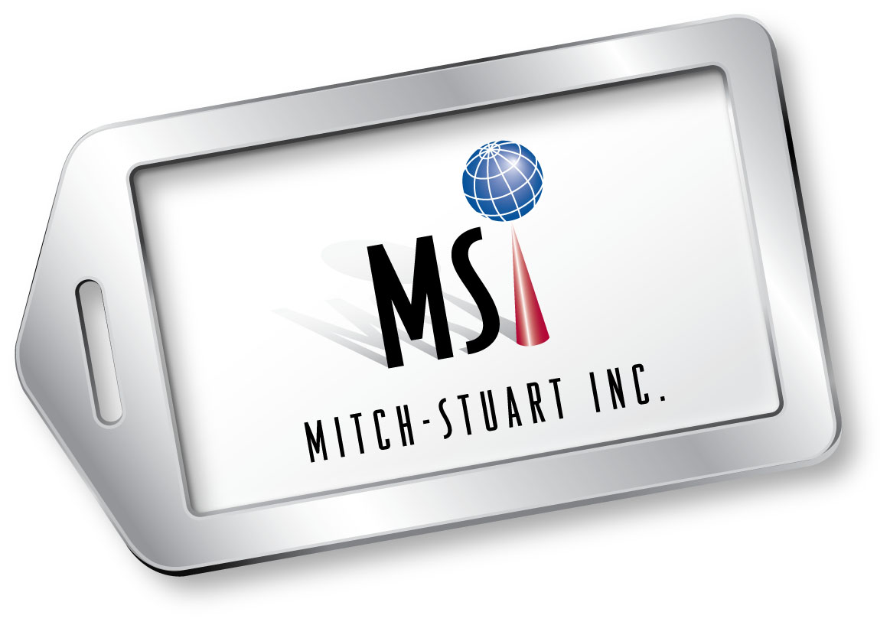

MITCH-STUART, INC.

FACT SHEET

Overview: Mitch-Stuart, Inc. specializes in innovative travel programs that assist nonprofit organizations in fundraising and provide incentives for businesses.

Background: Mitch-Stuart, Inc. was founded in 1993 and incorporated in 1994 by Michelle Cohen and Stuart Paskow. The company is headquartered in Orange County, California, with offices in Florida and Colorado. The colleagues recently launched an English corporation, Mitch-Stuart, Ltd.

Products/Services: Nonprofit Organizations
Destinations of Excellence® No-Risk Auction Packages
Perfect Places® Cause Related Marketing Program
Flight Certificates
American Airlines AAdvantage® Miles
Free concierge service

Businesses
Perfect Places® Cause Related Marketing Program
Incentive Flight Certificates
Hotel Stays
Gift Cards
American Airlines AAdvantage® Miles
Free concierge service

Highlights: Cohen and Paskow spearheaded the original launch of the American Airlines AAdvantage Fundraising™ program in 1993—the first of its kind frequent flyer mileage program for charities in the nation.

In 2005 they helped charities and the ailing tourism industry by creating Destinations of Excellence®, the first program that combines travel and hotel/resort stays as no-risk auction travel packages for charities.

In 2005, MSI received a Freddie Award for Distinguished Achievement; The Freddie is considered one of the most prestigious honors in the hospitality industry.

(more)

MSI Fact Sheet Page 2

In 2008, Cohen and Paskow established Mitch-Stuart, Ltd. in the
UK—introducing charity incentives to the UK and Europe.

In 2010, MSI launched Perfect Places®, a revolutionary means to provide additional money for nonprofit organizations through the first no-risk cause-related marketing program for businesses that turns dream vacations into charitable donations.

Mitch-Stuart has raised over a billion dollars for a variety of causes nationwide through its unique travel programs.

Principals: Mitch-Stuart’s management team has significant experience in fundraising, travel and tourism, direct marketing and new business development.

Michelle Cohen, President
West Coast Headquarters

Stuart Paskow, CEO
East Coast Office

Michael Upp, SVP Business Development
Midwest Office

Company Contacts: West Coast Headquarters
28202 Cabot Road, Suite 525
Laguna Niguel, CA 92677
(949) 276-9900/ (800) 574-9991
www.mitchstuart.com

East Coast Office
2020 NE 163rd Street, Suite 300
North Miami Beach, FL 33162
(305) 534-4487/ (888) 233-6636

Midwest Office
2935 S. Monroe Street
Denver, Colorado 80210
(303) 952-3560/ (866) 540-4993

Website: www.mitch-stuart.com

Media Contacts: Diane Pinnick
(714) 841-8924 / (714) 747-4574
dpcommunications@aol.com

Barbara Kimler
(949) 215-0417 / (949) 521-4962
bkimler@cox.net

# # #

