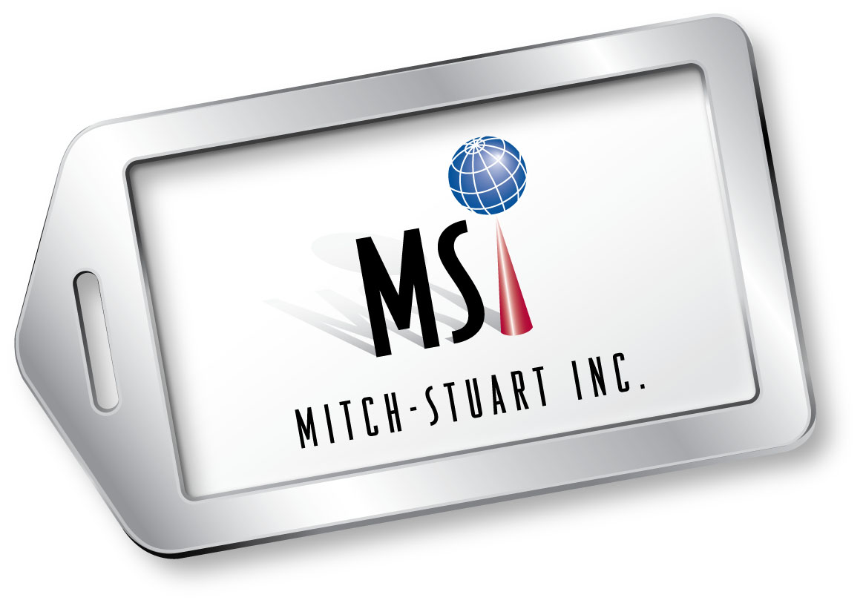
MICHAEL UPP
Senior Vice President Business Development
Mitch-Stuart, Inc.

Michael Upp brings more than 20 years of professional business development, leadership and management experience to Mitch-Stuart, Inc. As senior vice president of business development, Upp leads the business-to-business division in the company’s Midwest office. In this role, he develops new business opportunities on both the business-to-business side and among charitable organizations. Upp’s long-term goal for the company includes expanding its sports travel business.
Prior to joining Mitch-Stuart, Upp had spent the better part of his professional life in various sales management positions in the mortgage banking business. He created the first mortgage referral program for H&R Block franchise tax customers, became the company’s first national U.S. sales director and managed an operations and sales staff of over 60 people. Under his leadership, the company’s sales volume grew from $300 million to $5 billion.
Upp is a member of the Incentive Marketing Association (IMA) and charter member of the Incentive Travel Council. He was the recipient of IMA’s Rising Star Award in 2008.
Upp is a board member at Safe House Denver and charter member/co-chair of Safe House Men's Committee Against Domestic Violence. He graduated in 1988 from the University of Oklahoma with a B.B.A. in finance.

# # #

