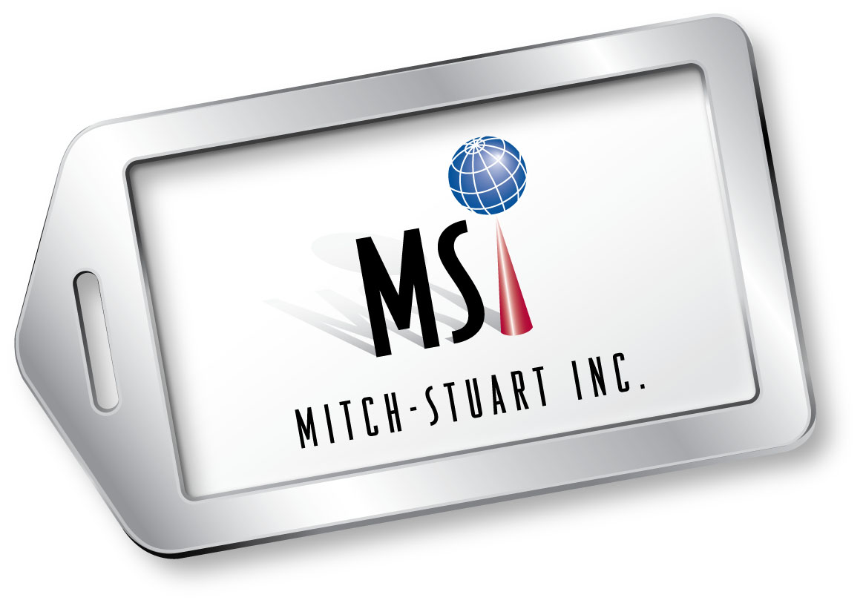
STUART PASKOW
Chief Executive Officer
Mitch-Stuart, Inc.

Stuart Paskow is chief executive officer of Mitch-Stuart, Inc. and heads its East Coast office. Mitch-Stuart, Inc., which he co-founded in 1994 with Michelle Cohen, is headquartered in California and has offices in Miami, Florida. The company is a recognized leader in providing unique travel programs that serve nonprofit organizations in fundraising and offer incentives for businesses.
As CEO, Paskow is responsible for sales and marketing and, with Cohen, consults on all aspects of the company.
Prior to forming Mitch-Stuart, Inc., Paskow was national communications director for an international nonprofit organization where he became the first fundraising executive to promote a philanthropic institute as a commercial product via innovative television and print campaigns. He and Cohen created the Frequent Funder Awards Program®—the first charitable giving program of its kind in the nation—for which they were recognized in national news media, including the front page of the Wall Street Journal.
In 1993, while working with Cohen on fundraising ideas for the same nonprofit organization, the pair created and managed the American Airline’s AAdvantage Fundraising® program, which introduced the unique concept of using airline miles as a nonprofit direct mail incentive and as donor premiums.
The following year, the colleagues officially formed Mitch-Stuart, Inc. and it became a full-service company, providing direct marketing consulting and creative services to charities. In 2005, their Destinations of Excellence® no-risk auction travel program opened up a new avenue for nonprofit fundraising while helping the ailing hospitality industry. The industry took note and honored the company with a Freddie Award (named in honor of aviation magnate Sir Freddie Laker) in 2005 for distinguished achievement. In addition, Paskow and Cohen authored the United Way Donor Awards program. To date, they've helped raise more than a billion dollars in revenue for over 10,000 charitable causes.
(more)

Paskow Bio Page 2

The team created a new program in 2010, Perfect Places®, a cause related marketing program that generates a new revenue stream for charities and provides businesses the opportunity to be philanthropic and provide an employee benefit.
Paskow served on the Small Business Administration Advisory Board and the New Jersey Hotel Association Board of Directors. He is former owner of the Harbor Island Spa Hotel in New Jersey and held the position of assistant professor of hotel management at the New York Institute of Technology where he helped to coordinate the school’s hotel management program. He is a founding member, creator and former board member of the International Arid Land Consortium. The members are the Jewish National Fund, Arizona State University, Israel, Jordan and Egypt. Its purpose is to assist farmers in desert areas of the Sub Sahara countries to use Israel-developed technology to successfully farm arid areas in the Middle East.
He served on the Incentive Customer Advisory Board for Fairmont Hotels & Resorts. His company, Mitch-Stuart, Inc., is a sponsor of the annual Nonprofit Times’ Power & Influence Top 50 gala and was honored as the founding charter sponsor.
Most recently, Stuart Paskow and Michelle Cohen were honored by receiving the national SCORE Award for the Outstanding Small Business Launched by an Individual 50+.
Paskow is recognized as a lifetime member of Strathmore’s Who’s Who global registry and network of outstanding professionals for his leadership in the travel incentive industry. He received a B.A. in political science from Washington Jefferson College in Pennsylvania and then attended Penn State, where he received an A.A. in hotel management.
# # #

