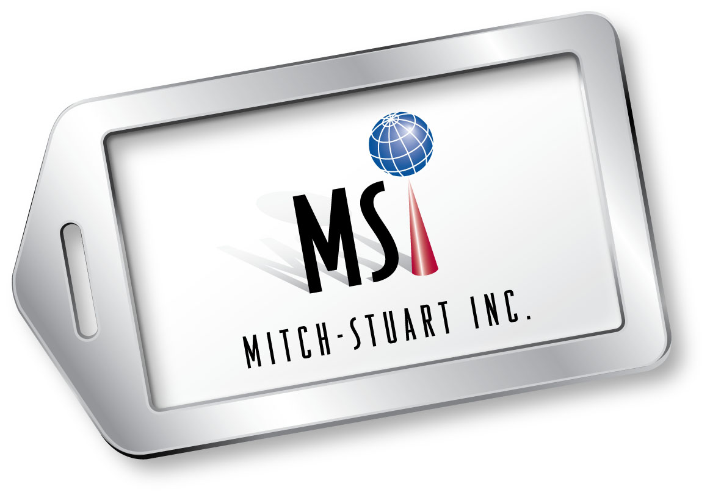

MICHELLE COHEN
President
Mitch-Stuart, Inc.
Michelle Cohen heads the West Coast office of Mitch-Stuart, Inc., which she co-founded with Stuart Paskow in 1994. The company specializes in unique travel programs that serve nonprofit organizations in fundraising and provide travel incentives for businesses.
As president, Cohen is responsible for the overall operations of Mitch-Stuart’s main headquarters in Orange County, Calif.
Cohen’s fundraising career spans over 25 years beginning with volunteerism and leadership at the community level. She was co-creator of a community-wide after school enrichment program. She later served as national director of development for the Jewish National Fund and chaired its National Communications Committee.
She and Paskow created the Frequent Funder Awards Program®—the first charitable giving program of its kind in the nation—which received national recognition, including the front page of the Wall Street Journal and which led to the creation of Mitch-Stuart, Inc.
Cohen’s greatest accomplishment is raising over a billion dollars for more than 10,000 charities through Mitch-Stuart’s innovative programs. She and her partner created and managed the American Airline’s AAdvantage Fundraising® program. Their Destinations of Excellence® no-risk auction travel program opened up a new avenue for nonprofit fundraising and bolstered hotel/flight sales following the downturn in the hospitality industry after 9-11. The industry honored them with a Freddie Award for their accomplishments. Cohen and Paskow also authored the United Way Donor Awards program and created a major donor gift with Tiffany & Co that was featured in 45 countries.
(more)

Cohen Bio Page 2

More recently, the team created Perfect Places®, a cause related marketing program that generates a creative revenue stream for charities and provides businesses the opportunity to be philanthropic with no out of pocket expense.
A recognized speaker at numerous national conventions, Cohen has served as a panelist at the Direct Marketing Association (DMA) Fundraising Day in New York. She is a member of the Association of Fundraising Professionals, and has served on the Incentive Customer Forums for Marriott Hotels & Resorts, The Ritz-Carlton and the Advisory Council for Fairmont Hotels and Resorts. Cohen was recognized as Woman of the Year for Temple Bat Yahm for her service to the community, as one of OC Metro’s 20 Women to Watch 2010 and was a featured nominee of the Orange County Business Journal’s Women In Business 2010 and 2010 Excellence in Entrepreneurship. In 2013, Cohen and Paskow were honored by receiving the prestigious national SCORE Award for the Outstanding Small Business Launched by an Individual 50+. She holds a B.A. degree in business from Cal State Northridge and a certificate in professional fundraising from UCI. She was honored with the Outstanding Alumni Award from the University of California, Irvine, for her success in nonprofit fundraising.

# # #

