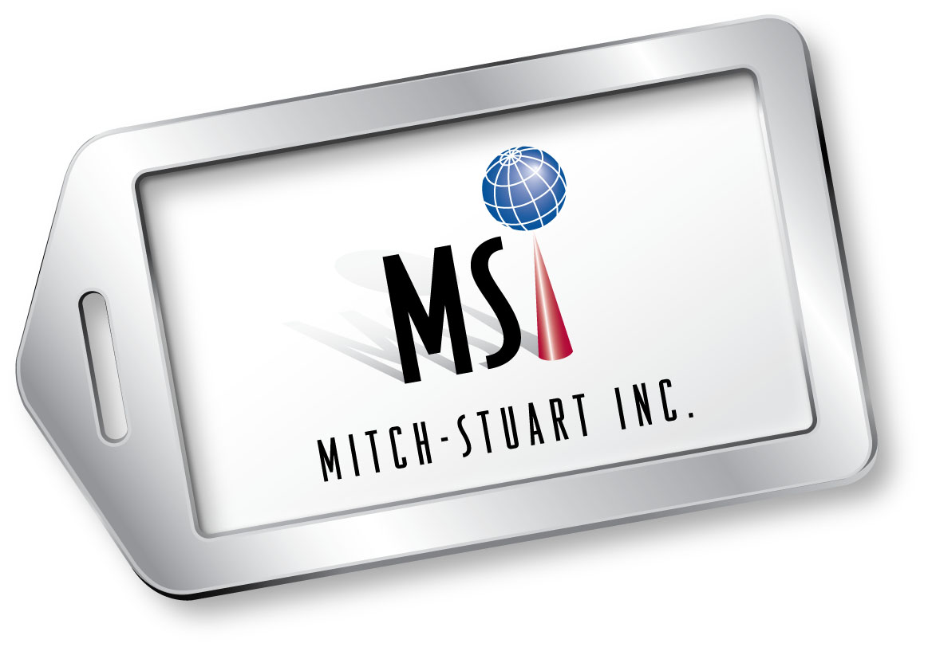

THE STORY OF MITCH-STUART, INC.

A COMPANY WITH CHARITY AT HEART

Thinking outside the box? Mitch-Stuart, Inc. is one company that not only thinks outside the box, it creates new boxes and puts stylish, altruistic, ribbons on them.
Mitch-Stuart, Inc. is synonymous with luxurious travel packages for business incentives and fundraising solutions that have helped nonprofit organizations raise over a billion dollars in revenue since 1994, demonstrating you can do well by doing good.
The company is a premier provider of travel packages worldwide, with a reputation for providing unrivaled customer service. It has received the prestigious Freddie Award from the hospitality industry for distinguished achievement (named in honor of legendary aviation magnate, Sir Freddie Laker) and the company reached the billion dollar fundraising mark for its nonprofit clients in 2010.
The company was recently honored by receiving the 2013 national SCORE Award for the Outstanding Small Business Launched by an Individual 50+.

How it all began:
Stuart Paskow, the national director of communications for an international charity, and Michelle Cohen, the charity’s national development consultant, worked closely together to consistently find new ways to raise funds. They created the innovative and highly successful Frequent Funder Awards Program® to reward the charity’s best donors. “We negotiated discounts with hundreds of shops, restaurants, hotels and car rental agencies that donors would find valuable and desirable,” says Cohen. In 14 months, the program raised $1.4 million and the average direct mail gift went from $46 to $126.
(more)

Mitch-Stuart Page 2
Then came the idea that would revolutionize the program and create a new market niche for airline miles. Cohen and Paskow were the first to use American Airlines AAdvantage® miles for a charitable cause, which increased their donations even more dramatically. The airline took note, asking them to develop and administer American’s division for charities in 1993.
“After a 10-minute caucus in the hallway, we came up with the name Mitch-Stuart, Inc. (for founders Michelle and Stuart) and we agreed to create and manage the American Airlines AAdvantage Fundraising Program®,” says Paskow.
AAdvantage miles have, since, helped thousands of nonprofit organizations raise over half a billion dollars. Cohen and Paskow, as Mitch-Stuart, Inc., continued as fundraising consultants to American Airlines for over 20 years. “The program is a winner for American Airlines,” says Cohen. “AAdvantage fundraising builds tremendous goodwill for the airline and it builds business, too.”
Soon afterwards, other airlines approached the colleagues to start similar projects to produce revenue and to capture loyal customers through charitable giving. An arm of Mitch-Stuart, Inc. also provided direct marketing consulting and creative services to charities. “We became a full-service outfit,” says Cohen.
Mitch-Stuart, Inc. became a pioneer in offering “trip a day” programs to radio stations. “We enjoy taking our knowledge and lending it to other industries,” says Paskow, who had also been the first to do television ads for charities earlier in his career. That out-of-box thinking came in handy after 9-11.
(more)

Mitch-Stuart Page 3

Providing opportunity in dire times:
A change was soon to come that would benefit charities in new ways and help the flailing tourism industry. Mitch-Stuart, Inc. was at the forefront. “Nine-11 happened, which hurt everyone in tourism,” says Paskow. Many hotel chains sold their hotels to investment groups and could no longer fulfill charities’ requests for free rooms. Airlines had contracted and could no longer fulfill the requests for free tickets.
In response, Mitch-Stuart, Inc. created the Destinations of Excellence® no-risk auction travel program, which opened up a new avenue for nonprofit fundraising and created a new industry. These auction packages, offered on consignment, featured luxurious worldwide travel/stay in association with United and American Airlines, Four Seasons, Marriott and Fairmont Hotels & Resorts, Hyatt Hotels & Resorts, The Ritz-Carlton, Disney, Celebrity and Royal Caribbean Cruises, Sandals & Beaches, among many others. They also created unique European tours, Fantasy Sports Trips, and exciting lifestyle experiences.
“Today, there’s no risk for the charity to offer the custom packages as auction items at their events and they receive every dollar over the base price. It’s a win-win for everyone involved,” says Cohen.
Nonprofit organizations contact Mitch-Stuart, Inc., whose travel experts assist them in choosing the appropriate trips to offer their audience, based on their fundraising goals. Bidders can get some great values on a fantasy sports trip to the Super Bowl or to see Tiger Woods in action at the Masters, a relaxing wine experience in the vineyards of Napa, a sizzling jazz excursion in New Orleans, a tasty culinary adventure in Paris or an exciting theater package in New York City. “Generosity also has its rewards,” says Cohen.
(more)

Mitch-Stuart Page 4
According to “The NonProfit Times,” “Travel is the ultimate incentive and Mitch-Stuart, Inc. is the leader in the category.” The hospitality industry took note and honored the company with a Freddie Award in 2005.
In addition to charitable auctions and donor incentives, Mitch-Stuart’s travel packages are increasingly used by businesses to enhance customer loyalty and to reward and motivate employees.
Mitch-Stuart offers both its business and nonprofit clients an in-house travel concierge service, at no cost, that ensures the trips are handled professionally and efficiently from start to finish.
The company has reached an outstanding level of success over 20 years, which is attributed to Paskow and Cohen and their uncanny ability to create innovative products and unique services combined with outstanding customer assistance.
“It’s a rewarding business that helps save lives, feed the hungry, and shelter the homeless. We’ve been proud to be a part of it,” says Cohen.

MSI Launched Revolutionary Program in 2010
During 2010, Mitch-Stuart, Inc. launched Perfect Places®, a revolutionary program that combines workplace giving with dream vacations for employees. Businesses of any size can feature a cause-related marketing program at no risk or expense. Perfect Places offers employees the opportunity to buy or bid on hundreds of low-cost travel packages as an ongoing employee benefit, to reward top performers, or they can be used as added excitement to events, conferences and corporate functions. A portion of every purchased trip goes directly to a targeted charity.
(more)

Mitch-Stuart Page 5
In addition, nonprofit organizations can introduce Perfect Places to current supporters or new, thereby deepening alliances, increasing their charitable donor pool, and generating a steady stream of incremental revenue. “Perfect Places can help charities strengthen their ability to raise funds by giving them a fresh avenue to reach new and potential audiences,” says Cohen.

The Future of Mitch-Stuart, Inc.
Their business model, which is altruistic yet profitable, is the base for future ventures, both domestic and international.
In early 2010, Mitch-Stuart, Inc. took its website to a new level of customer satisfaction. It launched an interactive site that offers its registered clients additional products and services that make purchasing vacation packages even easier. The site features MSI’s coveted vacation package catalogue and an update of brochures and other auction-related materials that can be customized. An event management module, complete with plan/purchase history, makes travel package procurement as easy as a few clicks on the computer keyboard. In addition, the company reached the billion dollar fundraising mark for its nonprofit clients.
In 2013, Mitch-Stuart, Inc. celebrated its 20th anniversary and received the prestigious national SCORE Award for the Outstanding Small Business Launched by an Individual 50+.
Always innovative. Always visionary. Always helping a good cause to the charity’s satisfaction. That is the formula for success of Mitch-Stuart, Inc. For additional information, visit the Mitch-Stuart, Inc. website at www.mitch-stuart.com.
###

